In C++, const keyword can be used in a number of ways as discussed below.

**Constant Variables:**

we can not assign const variable address to normal pointer(we assigned oly pointer to constant) or normal reference

Example:

Int const x=10;

Int *p=&x;//error

Const int *p=&x//correct//we need **pointer to constant**

Int *ref=&x;//error

Const Int &ref=x;//correct//we **need reference to constant**

**Constant Pointers**

[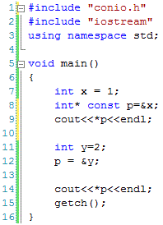](http://www.certiology.com/wp-content/uploads/2016/04/Constant-Pointers.gif)

//line 12 Error

**Pointer to Constant Variables**

[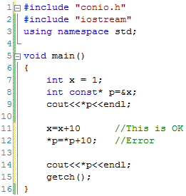](http://www.certiology.com/wp-content/uploads/2016/04/Pointer-to-Constant-Variables.gif)

**Constant Function Arguments**

[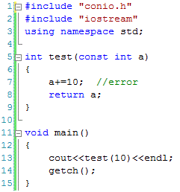](http://www.certiology.com/wp-content/uploads/2016/04/Constant-Function-Arguments.gif)

**Constant Data Members of a Class**

[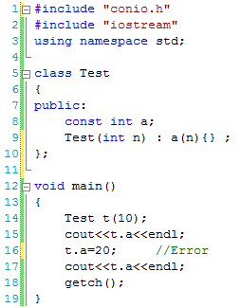](http://www.certiology.com/wp-content/uploads/2016/04/Constant-Data-Members-of-a-Class.gif)

**Constant Objects of a Class:**

1. If we declare an object of class as const then the values of data members cannot be changed later on. A const object can only call const functions. When a **function** is declared as **const**, it can be called on any type of object, **const** object as well as non-**const** objects.

[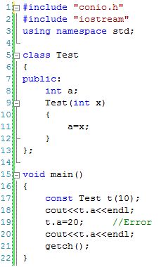](http://www.certiology.com/wp-content/uploads/2016/04/Constant-Objects-of-a-Class.gif)